Chapter 1
Self-Review Exercises 1.1
Fill in the blanks in each of the following statements:
a) Computers process data under the control of sets of instructions called programs.
b) The key logical units of the computer are the input unit, output unit, memory unit, arithmetic and logic unit, control unit and secondary storage unit.
c) The three types of languages they are assembly, machine and high-level.
d) The programs that translate high-level language programs into machine language are called compilers.
e) Android is an operating system for mobile devices based on the Linux kernel and Java.
f) Release candidate software is generally feature complete, (supposedly) bug free and ready for use by the community.
g) The Wii Remote, as well as many smartphones, use a(n) accelerometer which allows the device to respond to motion.

1.2 Fill in the blanks in each of the following sentences about the Java environment:
a) The java command from the JDK executes a Java application.
b) The javac command from the JDK compiles a Java program.
c) A Java source code file must end with the .java file extension.
d) When a Java program is compiled, the file produced by the compiler ends with the .class file extension.
e) The file produced by the Java compiler contains bytecodes that are executed by the Java Virtual Machine.

1.3 Fill in the blanks in each of the following statements

a) Objects enable the design practice of information hiding —although they may know how to communicate with one another across well-defined interfaces, they normally are not allowed to know how other objects are implemented.
b) Java programmers concentrate on creating classes, which contain fields and the set of methods that manipulate those fields and provide services to clients.
c) The process of analyzing and designing a system from an object-oriented point of view is called object-oriented analysis and design.
d) A new class of objects can be created conveniently by inheritance —the new class (called the subclass) starts with the characteristics of an existing class (called the superclass), possibly customizing them and adding unique characteristics of its own.
e) The Unified Modeling Language is a graphical language that allows people who design software systems to use an industry-standard notation to represent them.
f) The size, shape, color and weight of an object are considered attributes of the object’s class.

Exercises 1.4 Fill in the blanks in each of the following statements:
a) The logical unit that receives information from outside the computer for use by the computer is the input unit.
b) The process of instructing the computer to solve a problem is called computer programming.
c) Assembly language is a type of computer language that uses English-like abbreviations for machine-language instructions.
d) Output unit is a logical unit that sends information which has already been processed by the computer to various devices so that it may be used outside the computer.
e) Memory unit and secondary storage unit are logical units of the computer that retain information.
f) Arithmetic and logic unit is a logical unit of the computer that performs calculations.
g) Control unit is a logical unit of the computer that makes logical decisions.
h) High-level languages are most convenient to the programmer for writing programs quickly and easily.
i) The only language a computer can directly understand is that computer’s machine language.
j) Control unit is a logical unit of the computer that coordinates the activities of all the other logical units.

1.5 Fill in the blanks in each of the following statements:
a) The java programming language is now used to develop large-scale enterprise applications, to enhance the functionality of web servers, to provide applications for consumer devices and for many other purposes.
b) C initially became widely known as the development language of the UNIX operating system.
c) The Transmission Control Protocol ensures that messages, consisting of sequentially numbered pieces called bytes, were properly routed from sender to receiver, arrived intact and were assembled in the correct order.
d) The C++ programming language was developed by Bjarne Stroustrup in the early 1980s at Bell Laboratories.
1.6 Fill in the blanks in each of the following statements:
a) Java programs normally go through five phases— edit, compile, load, verify, and execute.
b) A(n) integrated development environment provides many tools that support the software development process, such as editors for writing and editing programs, debuggers for locating logic errors in programs, and many other features.
c) The command java invokes the Java Virtual Machine, which executes Java programs.
d) A(n) Java Virtual Machine is a software application that simulates a computer, but hides the underlying operating system and hardware from the programs that interact with it.
e) The class loader takes the .class files containing the program’s bytecodes and transfers them to primary memory. f) The examines bytecodes to ensure that they’re valid.
f) The bytecodes verifier examines bytecodes to ensure that they’re valid.

1.7 Explain the two compilation phases of Java programs:
Ans:
The two compilation phases of Java programs are the; compile-time compilation, and the run-time compilation.
First Phase: (compile-time compilation)
The Java compiler (javac) translates the human-readable Java source code (stored in .java files) into bytecodes (stored in .class files). This phase produces portable bytecodes that can be distributed and run on any machine with a Java Virtual Machine.
Second Phase: (run-time compilation)
The Java command is used to execute the program here. The Java Virtual Machine loads the bytecodes, verifies them, and then translate/executes them into the native machine language for the underlying computer.

1.8 One of the world’s most common objects is a wrist watch. Discuss how each of the following terms and concepts applies to the notion of a watch: object, attributes, behaviors, class, inheritance (consider, for example, an alarm clock), modeling, messages, encapsulation, interface and information hiding.
Ans:
- Object: A specific wrist watch is an object with its own unique identity, state, and behavior.
- Attributes: Also called properties. These describes the current state of a particular watch. Examples: currentTime (e.g., 5:09), brand (e.g., “Casio”), batteryLevel (e.g., 98%), dateDisplayed, alarmTime (true/false), etc.
- Behaviors: Also called operation/methods. These are the things a watch can do or that can be done to it. Examples: setTime(), displayTime(), setAlarm(), resetStopwatch(), etc.
- Class: This is the blueprint that defines what all wrist watches have in common. This would include the attributes (fields) and behaviors (methods) that every watch of that type shares.
- Inheritance: A specialized type of watch can inherit from a more general one. For example: A basic “WristWatch” class defines common features (time display, set time, etc.). An “AlarmWristWatch” class can inherit from “WristWatch”, gaining all its attributes and behaviors automatically, and then add new ones (e.g., alarmTime, setAlarm(), ring(), etc.).
- Modeling: We create a software model of a real-world wrist watch by identifying its essential attributes and behaviors, then representing them in class and objects.
- Messages: Other objects or the user via buttons/touch, send messages to the watch to request it to perform a behavior. Examples: A) User presses “Mode” button (it sends message “changeMode”). B) Phone syncs time (it sends message “setTime” __newTime)
- Encapsulation: The watch hides its internal implementation details and only exposes a public interface. You don’t need to know how the quartz crystal oscillates or how the microprocessor stores time _you just interact via buttons, crowns, touchscreen, or methods like “setTime ()” and “getCurrentTime ()”.
- Interface: The watch provides a well-defined interface _the set of buttons, crown, and touchscreen gestures that users can use to interact with it. The interface is what matters; the internal workings can change without affecting how you use the watch.
- Information Hiding: Closely related to encapsulation. You cannot directly access or modify the internal timer circuit, memory registers, or gear mechanisms –you can only use the provided interface. This prevents accidental misuse and allows the manufacturer to improve the internals without changing how users operate it.

Making a Difference
1.9 (Test-Drive: Carbon Footprint Calculator)
Some scientists believe that carbon emissions, especially from the burning of fossil fuels, contribute significantly to global warming and that this can be combatted if individuals take steps to limit their use of carbon-based fuels. Organizations and individuals are increasingly concerned about their “carbon footprints.” Websites such as TerraPass http://www.terrapass.com/carbon-footprint-calculator/ and Carbon Footprint http://www.carbonfootprint.com/calculator.aspx provide carbon-footprint calculators. Test-drive these calculators to determine your carbon footprint. Exercises in later chapters will ask you to program your own carbon-footprint calculator. To prepare for this, use the web to research the formulas for calculating carbon footprints.
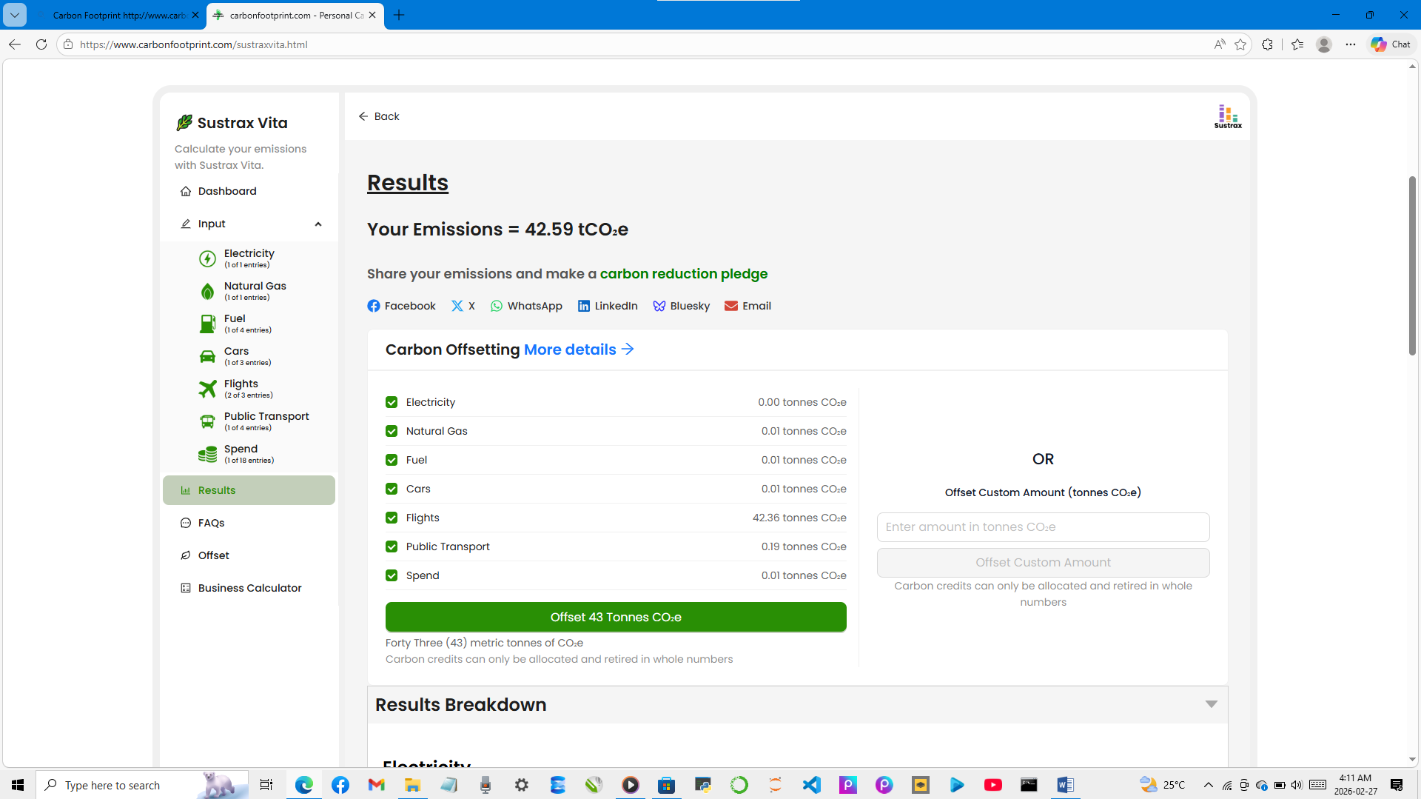
1.10 (Test-Drive: Body Mass Index Calculator)
Obesity causes significant increases in illnesses such as diabetes and heart disease. To determine whether a person is overweight or obese, you can use a measure called the body mass index (BMI). The United States Department of Health and Human Services provides a BMI calculator at http://www.nhlbi.nih.gov/guidelines/obesity/BMI/ bmicalc.htm. Use it to calculate your own BMI. A forthcoming exercise will ask you to program your own BMI calculator. To prepare for this, use the web to research the formulas for calculating BMI.

1.11 (Attributes of Hybrid Vehicles)
Hybrid vehicles are becoming increasingly popular, because they often get much better mileage than purely gasoline-powered vehicles. Browse the web and study the features of four or five of today’s popular hybrid cars, then list as many of their hybrid-related attributes as you can. Some common attributes include city-miles-per-gallon and highway-miles-per-gallon. Also list the attributes of the batteries (type, weight, etc.).
- Toyota Camry Hybrid (2026)
- A top-rated midsize sedan, all-hybrid lineup now.
- MPG: Up to 53 city/ 50 highways/ ~51 combined (varies by trim).
- Powertrain: 2.5L inline-4 + electric motor(s), total ~208 hp.
- Battery: Lithium-ion (compact, typically ~1-1.5 kWh usable for hybrid system).
- Battery attributes: Lightweight (contributes to efficiency), long warranty (often 8-10 years/100k-150k miles), located under rear seat or trunk.
Other attributes: Smooth eCVT transmission, excellent reliability, spacious interior, advanced safety features.
- Honda Civic Hybrid (2026)
  - Highly praised compact with strong performance and efficiency.
- MPG: Up to 51 city/ 44 highways/ 48 combined (EX-L trim); 46/41/44 for others.
- Powertrain: 2.0L inline-4 + electric motor, total ~204-212 hp.
- Battery: Lithium-ion, ~1.04 kWh capacity.
- Battery attributes: Small and efficient, positioned for balanced weight distribution; regenerative braking recharges it effectively.
Other attributes: Spacious cabin, refined ride, strong acceleration for a hybrid, comprehensive driver aids.
- Honda Accord Hybrid (2026)
- Midsize sedan known for comfort and efficiency.
- MPG: Up to 53 city/ 50 highways/ ~51 combined (varies by trim).
- Powertrain: 2.5L inline-4 + electric motor(s), total ~208 hp.
- Battery: Lithium-ion (compact, typically ~1-1.5 kWh usable for hybrid system).
- Battery attributes: Lightweight (contributes to efficiency), long warranty (often 8-10 years/100k-150k miles), located under rear seat or trunk.
Other attributes: Smooth eCVT transmission, excellent reliability, spacious interior, advanced safety features.

- F

1.12 (Gender Neutrality)
Many people want to eliminate sexism in all forms of communication. You’ve been asked to create a program that can process a paragraph of text and replace gender-specific words with gender-neutral ones. Assuming that you’ve been given a list of gender-specific words and their gender-neutral replacements (e.g., replace both “wife” and “husband” with “spouse,” “man” and “woman” with “person,” “daughter” and “son” with “child”), explain the procedure you’d use to read through a paragraph of text and manually perform these replacements. How might your procedure generate a strange term like “woperchild?” You’ll soon learn that a more formal term for “procedure” is “algorithm,” and that an algorithm specifies the steps to be performed and the order in which to perform them. We’ll show how to develop algorithms then convert them to Java programs which can be run on computers.

